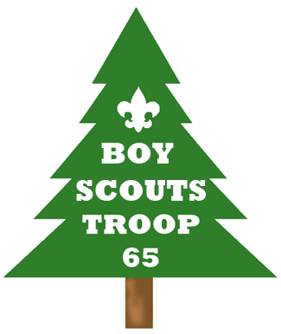
Christmas Trees, Wreaths, & Roping Sale!
Please support our Scouts by purchasing your fresh cut Fraser Fir Christmas Trees, Fraser Fir Wreaths, and White Pine Roping (Garland) from our fundraiser! We deal directly with the tree farm to keep the prices low, and all profits go directly to support our Boy Scout Troop activities. Our trees are cut just before delivery so they have not been sitting for weeks before you get them! We have always had nothing but consistent compliments on these items and we only do pre-orders, so there are none that wind up wasting away on a tree sale lot.
Your items will be available for pick up at B. Everett Jordan ball field on Wednesday, November 21st between 4 pm and 7 pm, so you will have them in time for your traditional Thanksgiving Tree-Trimmings!
The Parents of Troop 65 sincerely appreciate your support of our Scouts!
Please keep the top of this form and bring it with you to pick up your items. Minimum deposit required of $20 per tree and $10 per wreath/roping order.

KEEP AND BRING TO PICKUP | ITEM | SIZE | PRICE | QTY | TOTAL
 | Fraser Fir Trees | 5ft – 6ft | $ 30.00
 |  | 6ft – 7ft | $ 40.00
 |  | 7ft – 8ft | $ 50.00
 |  | 8ft – 9ft | $ 70.00
 |  | 9ft – 10ft | $ 90.00
 | Fraser Fir Wreaths | 12” frame | $ 20.00
 | White Pine Roping | 75ft Roll | $ 30.00
 | Please make checks payable to Troop 65.  Thanks for your support!  PICKUP – Wed, Nov 21 – 4-7pm |  |  | TOTAL DUE
 |  |  |  | DEPOSIT AMOUNT
 |  |  |  | BALANCE DUE

RETURN TO SCOUT WITH PAYMENT | Name: |  | Phone:
 | Address: |  | Other Phone:
 | Scout Name:
 | ITEM | SIZE | PRICE | QTY | TOTAL
 | Fraser Fir Trees | 5ft – 6ft | $ 30.00
 |  | 6ft – 7ft | $ 40.00
 |  | 7ft – 8ft | $ 50.00
 |  | 8ft – 9ft | $ 70.00
 |  | 9ft – 10ft | $ 90.00
 | Fraser Fir Wreaths | 12” frame | $ 20.00
 | White Pine Roping | 75ft Roll | $ 30.00
 | Please make checks payable to Troop 65.  Thanks for your support! |  |  | TOTAL DUE
 |  |  |  | DEPOSIT AMOUNT
 |  |  |  | BALANCE DUE

